***Note: Below shows the guidelines which you may consider when writing your research proposal***

**Topic: Driving assisting technology for NZ tourist drivers**

**Problem statement**:

Research in the area of health and safety of New Zealand road users, to help in preventing injuries and deaths on the road

The only resource to assist tourist drivers in adjusting to local conditions is a band that attaches to the steering wheel.

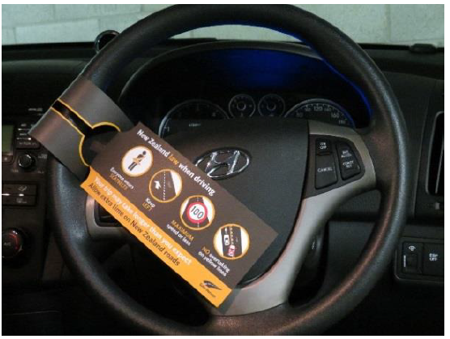

(Safety tags for visiting drivers to go nationwide, 2014)

**Research question:**

What present technology can be used to reduce the level of accidents on New Zealand roads that are caused by tourist drivers and how?

**What to research on ( example in 4 key area):**

**1) What are the key causes of tourist accidents?**

e.g. Speeding, driving on the wrong side, unfamiliar road signage.

Specific literature:

* Analysing cases, crash investigation reports.

**2) What present technology has potential to resolve these causes?**

e.g. Computer Vision, GPS, wireless communications etc.

Specific literature:

* Current vehicle technology articles, tech reports, sensors.

**3) Further research into understanding the technology and how it can be implemented?**

Specific literature;

* Datasheets, technology study/thesis.

**4) Research into methods of communicating to a driver via technology**.

e.g. the optimum method will provide a perfect ratio between safety vs effectiveness.

Specific literature:

* Visual perception studies, journals and articles.

**Methods ( how do you go about doing it):**

1. Using:

* Image processing and software algorithm method
* Camera (eg. Logictech webcam)
* Laptop
* Mobile phone for apps

2) Testing technology and developing a concept device to physically assist a tourist driver. An example of this would be computer vision algorithm to track the lanes the car is within, and if the driver crosses into the wrong side of the road the dash mounted device could alert the driver of this.

